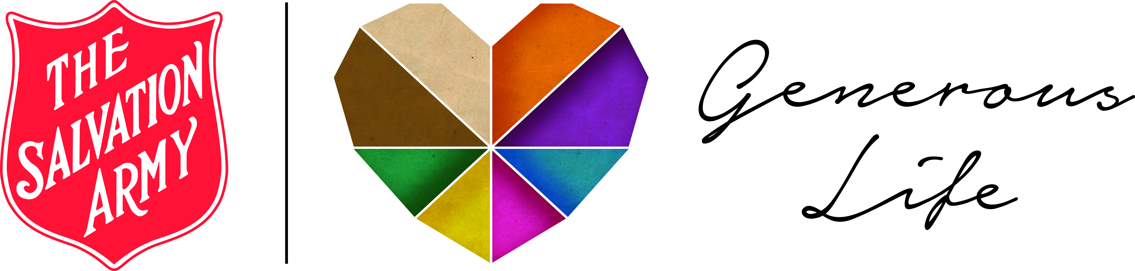  "GRATITUDE unlocks  the fullness of life.”  (Max Lucado)  Web: salvos.org.au/generouslife | "GRATITUDE unlocks  the fullness of life.”  (Max Lucado)  Web: salvos.org.au/generouslife
"GRATITUDE unlocks  the fullness of life.”  (Max Lucado)  Web: salvos.org.au/generouslife | "GRATITUDE unlocks  the fullness of life.”  (Max Lucado)  Web: salvos.org.au/generouslife
"GRATITUDE unlocks  the fullness of life.”  (Max Lucado)  Web: salvos.org.au/generouslife | "GRATITUDE unlocks  the fullness of life.”  (Max Lucado)  Web: salvos.org.au/generouslife
"GRATITUDE unlocks  the fullness of life.”  (Max Lucado)  Web: salvos.org.au/generouslife | "GRATITUDE unlocks  the fullness of life.”  (Max Lucado)  Web: salvos.org.au/generouslife
"GRATITUDE unlocks  the fullness of life.”  (Max Lucado)  Web: salvos.org.au/generouslife | "GRATITUDE unlocks  the fullness of life.”  (Max Lucado)  Web: salvos.org.au/generouslife

