Aligning the Prosci® ADKAR model with LDIS

This template will help you to identify the stages of ADKAR and how they align with LDIS.

Prosci® ADKAR model

ADKAR is both an individual journey, and an organisational journey through change.
Individuals will journey through the ADKAR stages at their own pace, and may need support from a manager or leader to help them progress through the stages.
On an organisational level, specific change activities should occur in line with LDIS process changes that ensure the organisation is journeying through the change process effectively.

Use the template below to identify what organisational activities will take place, and when they will occur within the LDIS framework.
Some examples of how to align ADKAR & LDIS activities can be found on page 4 of the LDIS Toolkit

ADKAR alignment with LDIS?

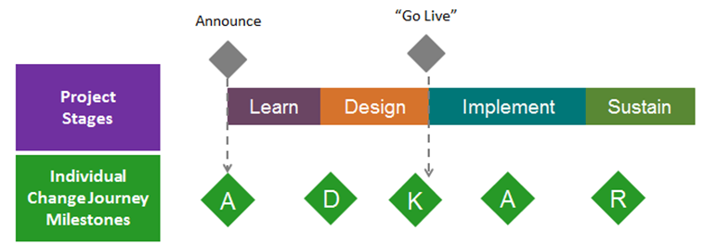
ADKAR Stage | Description of activities | Who is responsible for the activity? | What LDIS stage will this take place in?
Awareness | This is the ‘why’ stage. It’s about helping people to become aware of the need for change. If you don’t answer the why, people won’t buy into the change and you’ll be spinning your wheels. |  | Learn  Design
Desire | This is the ‘what’s in it for me’ (WIFM) stage. Research shows that it’s better if communication from this stage comes from the next level of manager up, rather than high level mgt. The immediate manager needs to be sold on the new way of operating, and able to share this information, or else no amount of communicating from high level leadership will make a difference. |  | Learn & Design
Knowledge | This is the training/educating/equipping stage. Training people at this stage if they haven’t yet reached the ‘Desire or WIFM’ is unlikely to be effective.  Training needs to take place fairly close to when it will be used. If it’s too early or too long before it’s needed, it won’t be remembered.  The most effective training is where there is a lot of group learning (rather than a talking head giving information). |  | Implementation
Ability | There is a difference between having knowledge, and then having the ability to apply it.  There is a bit of a line between knowledge and ability. Knowledge/training can be delivered remotely, but ability is only something that can be done in the real situation. This step requires a relationship, ongoing conversations, and more than one point of contact. You don’t just create a plan – you need to be regularly checking and working through with people to make sure they are operating in the new way. |  | Implementation
Reinforcement | This is encouragement, affirmation, performance evaluation, accountability, celebration, sharing stories. Reinforcement activities ensure that the new way of operating is embraced in the long term. |  | Implementation  Reinforcement

